- 1.Data graph of sales forecast prediction of next 6 months
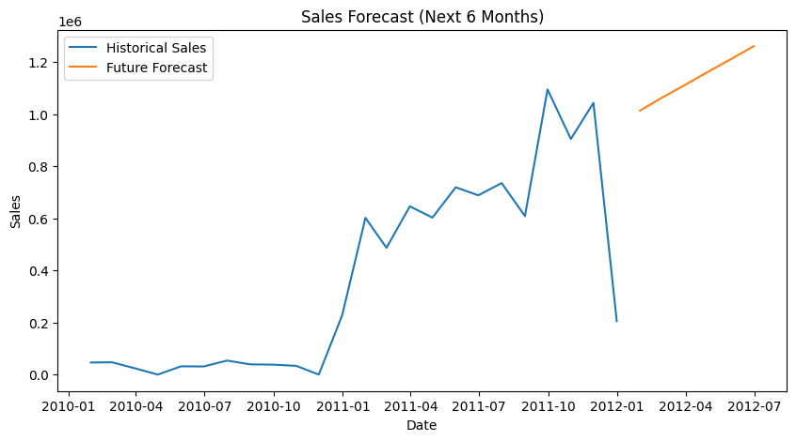

- what the forecast means
- The model performance was evaluated using error metrics:
- MAE (Mean Absolute Error) → Measures the average prediction error.
- RMSE (Root Mean Squared Error) → Measures overall prediction accuracy and penalizes large errors.
These metrics indicate how close the predicted sales values are to the actual sales values.
The model was used to forecast sales for the next six months.
The predicted monthly sales values ranged approximately from:
- 1,013,995 to 1,261,204
This indicates a gradual increase in sales over time.
The forecast suggests that the business may experience steady growth in future months

- how a business can use it for planning
- Inventory Planning (Buying Raw Materials)
Since sales are predicted to increase gradually, the business should:
Order slightly more stock each month
Avoid understocking
Example:
Month | Predicted Sales | Action
Month 1 | ~1.01M | Normal stock
Month 3 | ~1.11M | Increase stock slightly
Month 6 | ~1.26M | Prepare higher inventory

Business Decision
The company should gradually increase purchasing of raw materials to match the expected rise in demand.

Example:
Retail store → Buy more products
Manufacturer → Buy more raw materials

2. Production Planning
Your model shows steady growth, not sudden spikes.
So production should be: gradually increases with growth with no sudden spikes of growth or abnormality
Business Decision
The company should slowly increase production capacity instead of making sudden changes.
Example:
- Increase production by 5–10% monthly
- Avoid overproduction

3. Avoid Overstocking
Without forecasting, companies often produce too much.
Indication
our forecast indicates the growth of production increases gradually, so focusing stocking the ratio above would cause underload on material demand
rather understocking with increased demand
but overstocking would cause excess inventory

Business Decision
The company should align production with forecasted demand to reduce excess inventory.
But to buy before demand

4.Staffing Planning
If sales increase:
- More workers may be needed
- More shifts may be required
Example:
Month 6 forecast:
≈ 1.01 - 1.26 million
Higher workload expected.
Business Decision
The company may need additional staff or longer working hours if sales continue to increase.

5. Cash Flow Planning
Sales forecasts help plan money.
Example:
Predicted revenue:
~1 million per month
Business can estimate:
- Expected income
- Expenses
- Profit
Business Decision
The forecast helps estimate future revenue and plan budgets accordingly.
6. Marketing Planning
If sales are increasing:
- Business can invest in marketing
- Expand operations
If sales were decreasing:
- Reduce spending
- Offer discounts
Business Decision
The forecast suggests stable growth, so the company can plan expansion or marketing campaigns confidently.

